# Contact Book:

## Code:

|  |
| --- |
| #include<iostream>  #include<vector>  #include<string>  using namespace std;  int menu()  {  int n;  cout << "\n______________________________";  cout << "\n-----Contact Books------";  cout << "\n1. Add New Contact.\n2.View Contact.\n3. Delete Contact.\n4. Exit.\n Choose (1-3): ";  cin >> n;  return n;  }  class contact  {  public:  string name, ph_nu;  void input()  {  cout << " Enter the Name: ";  cin.ignore();  getline(cin, name);  cout << "Enter the Phone Number: ";  getline(cin, ph_nu);  }  void disp()  {  cout << "Name: " << name << "\nPhone Number: " << ph_nu;  }  };  int main()  {  string del_name;  vector<contact> ct;  int choice;  bool temp = true;  while (temp)  {  choice = menu();  switch (choice)  {  case 1:  {  system("cls");  contact newcontact;  newcontact.input();  ct.push_back(newcontact);  cout << "Contact Added Successfully.";  break;  }  case 2:  {  system("cls");  if (ct.empty())  {  cout << "No Contacts added!";  }  else  {  cout << "\t\t*****List of Contacts*****\n";  for (int i = 0; i < ct.size(); i++)  {  ct[i].disp();  cout << endl;  }  }  break;  }  case 3:  {  system("cls");  if (ct.empty())  {  cout << "No contact to delete";  }  else  {  cout << "Enter the name of the contact to delete: ";  cin.ignore();  getline(cin, del_name);  auto it = find_if(ct.begin(), ct.end(), [&del_name](const contact& c) {  return c.name == del_name;  });  if (it != ct.end())  {  ct.erase(it);  cout << "Contact deleted Successfully.";  }  else  {  cout << "Contact not found.";  }  }  break;  }  case 4:  {  system("cls");  cout << "Exiting the program";  temp = false;  break;  }  default:  {  cout << "Wrong Choice! Select from 1-3. ";  break;  }  }  }  return 0;  } |

## Output:

* Menu form

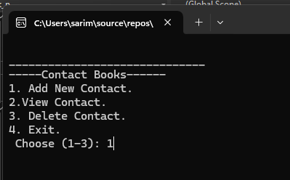

* Adding new contact

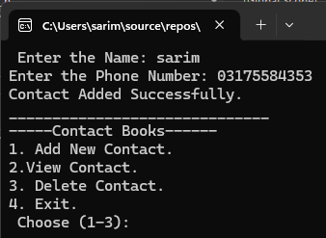

* Adding second contact

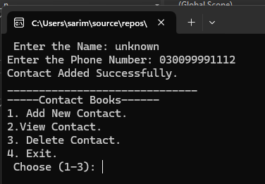

* Viewing list of contacts.

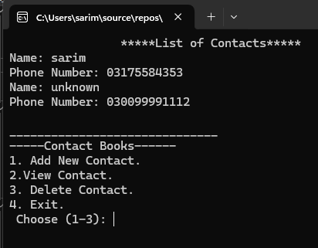

* Deleting one contact.

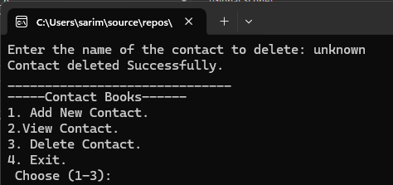

* List of contacts after deletion

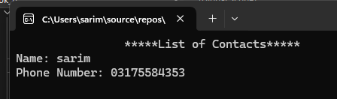

## Explanation:

This is the simple program which work as the contact book it gives user multiple options to do operations like

1. Add new contact.
2. View contacts.
3. Delete Contact

I used **vector** and **classes** to implement this, the class of contact holds the data and then I used **vectors** to store multiple objects of **contact class** so I can save multiple data in multiple objects of class, this program uses switch to get user choice and according to it performed different functions. The **deletion** is done by searching the name in the vector and erasing it using **erase()** function.

I have attached the test cases to check.